Set the clock registers as 0, GPR0=2, GPR1 = 2, GPR2 = 2, GPR 3=2; IX1 =2, IX2 =2, IX3 =2;

and execute the following instructions:

AIR 0,1;

SIR 1,1;

AIR 2,2;

SIR 3,1;

STX 1,10;

STX 2,11;

STX 3,12;

AIR 0,1;

AIR 1,4;

AIR 2,4;

AIR 3,8;

The correct result should be :

GPR0 = 4, GPR1=5, GPR2 = 8, GPR3= 9; M[10] = 2, M[11] = 2,M[12] = 2.

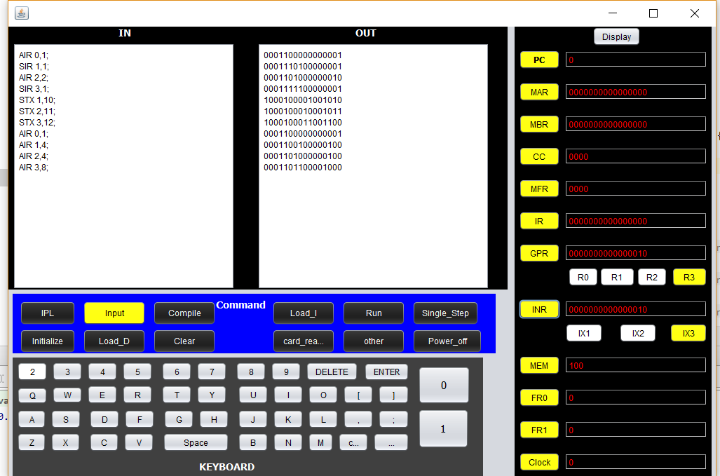

Hit run button and we got the result:

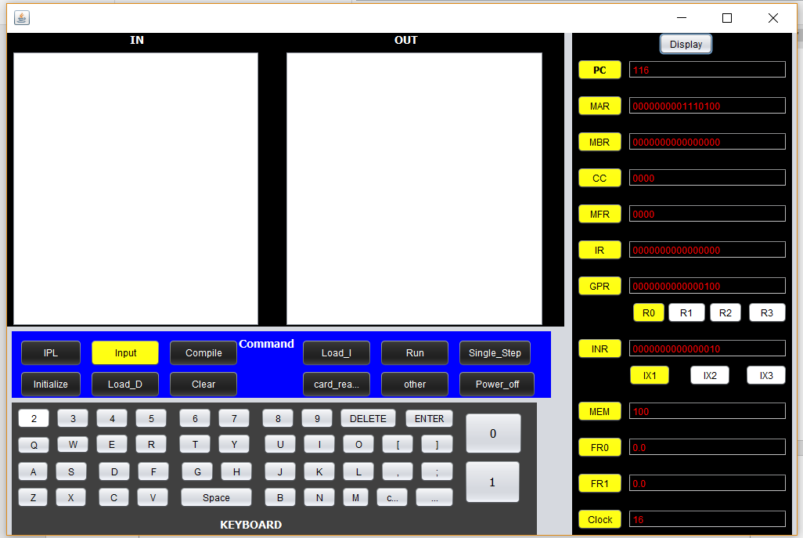

We can see that the results are correct. And the clock value is 16.

Each stage will cost 1 circle, and each instruction will step through 6 stages. If there is no pipeline, the running time will be 10 instructions \* 6 = 60 circles. Since this is a pipeline simulator, the running time is 10 cycle +6 cycle = 16 cycles.